# CS 255 System Design Document Template

This template lays out all the different sections that you need to complete for Project Two. Each section has guidance to prompt your thinking. You will need to continually reference the interview transcript as you work to make sure that you are addressing your client’s needs. There is no required length for the final document. Instead the goal is to complete each section based on what your client’s needs are. Remove this note when you are finished, and replace all bracketed text with the relevant information.

## UML Diagrams

### UML Use Case Diagram

### UML Activity Diagrams

*[You were asked to choose* ***two*** *use cases and create* ***two*** *activity diagrams, one for each use case. Please insert* ***both*** *of your activity diagrams here. Check to make sure that you included appropriate components and symbols and that your design meets the client’s needs.]*

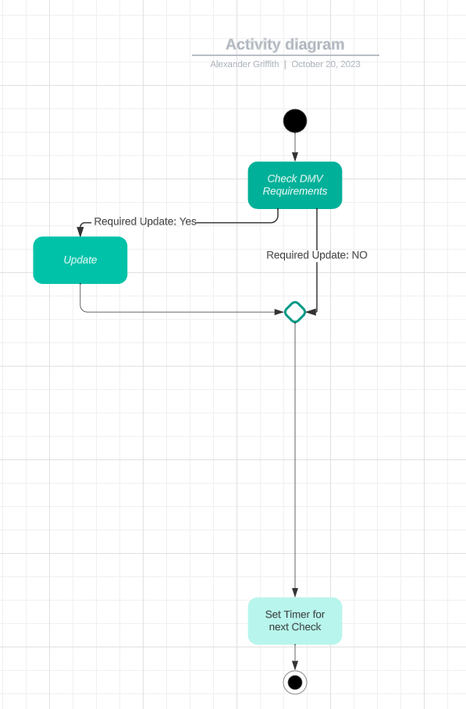

### UML Sequence Diagram

### UML Class Diagram

## Technical Requirements

*[Based on the diagrams you have created, describe the technical requirements of your system. These requirements should address the required hardware, software, tools, and infrastructure necessary for your system design.]*

The technical requirements for my system would be access to a Cloud-Based Host Server, Personal means of system access for all Users (a computer or smartphone would be the preferable means), the ability for the system to interact with most web browsers, and potentially third-party application integration when it comes to class materials for students (i.e., YouTube etc.).